Marking and Feedback Policy
2025-2026




Approved by: | Governing Body | Date: June 2025
Last reviewed: | June 2025
Next review due: | June 2026

Marking and Feedback
Aims
- Provide consistency and continuity in marking throughout the school so that pupils have a clear understanding of teacher expectations and to support teacher workload
- To set out our expectations for high quality but manageable feedback and marking and provide a coherent picture of outstanding practice in marking
- To use marking as a tool for formative ongoing assessment, ensure children are effectively challenged and visible progress is evident through a dialogue which aids progression
- To give teachers, teaching assistants and peers the skills for effective feedback
- To develop positive attitudes to learning and achievement

Principles and Purpose
Marking and feedback should:
- manageable for teachers and accessible to pupils and relate to the learning intention
- Give recognition and praise for achievement
- Give clear strategies for improvement and result in better pupil achievement
- Allow specific time for pupils to read, reflect and respond to marking
- Be personalised to individual learning needs and inform future planning and group tasks
- Be consistent to ensure impact and close the gap to end of year expectations (deepening learning)

Teacher Expectations
- To be effective the marking of children’s work must be both regular and frequent. It is sometimes appropriate to mark during a lesson and sometimes at the end of a task. During focus group work, marking is best carried out with the child present. To have impact, marking should be completed as soon as possible after work is completed, usually before the next lesson
- Where work has been set for a cover teacher, the class teacher should indicate how the work should be marked and, in the case where this does not take place, the class teacher will ensure that the work is marked according to the school policy
- Use marking to identify groups of children who will need to work with the class teacher / TA the next day to consolidate understanding on the same task before moving on.
- All work (including homework) will be marked in accordance with the subject specific expectations using the identified types of marking
- Pupils’ work is marked in GREEN. Teacher’s handwriting in comments must be legible to the child and follow the cursive handwriting script
- Children’s responses to marking questions will be in PURPLE
- Each piece of work will have a Learning Objective (LO)
- Each piece of work will be indicated as independent, teacher support or other adult support
- As part of the daily classroom routine it is expected that at the start of each session, children read the teacher comment from the lesson before and if appropriate respond to it in green pen

Pupil Expectations
- Read and respond to the comments made by adults in their books daily
- Take pride and care in the presentation of their books reflecting the high standard that is expected e.g., never use graffiti, doodle or scribble on or in books
- Underline titles using a ruler and never leave unnecessary gaps
- Take time to correct and finish off work where appropriate
- Cross out mistakes using a pencil / pen and ruler
- Use quality-writing equipment appropriate to the year group, consistently using either pen or pencil but not moving between them. Not use felt tip pens in workbooks
- Use a pencil for drawing or diagrams
- Record the LO and date at the beginning of each new recorded learning.

Planning, Assessment and Marking Flow Chart

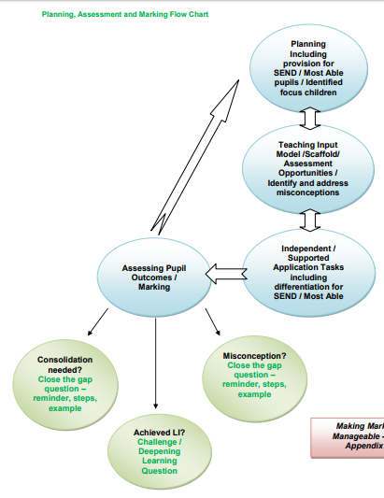

Types of Marking
‘Close the gap’ marking
All work to be acknowledged with a minimum of a tick and highlighting of the LO. This acknowledgement should always relate to the Learning Objective. Teachers focus upon the learning objective of the task and success criteria / steps to success. Successful achievement is highlighted in pink and areas for development are highlighted in green, with a corresponding written prompt. The emphasis should be on next step targets and require a green pen question, which allows the child to demonstrate the understanding missed in the piece of work.
When gap-marking teachers should:
- Read the entire piece of work.
- Highlight examples of success criteria using a highlighter
- Provide a question which should help the pupil to ‘close the gap’ between what they have achieved and what they could have achieved. Where children have met all the success criteria a challenge / depth of learning question should be used.
- Success criteria can be shared on the IWB or below their LO in books.

Comment Marking
The fundamental aspect of marking is to check for errors and misconceptions in the work, sometimes comments are appropriate to track visible progress e.g., Names need capital letters e.g., Peter, London, please make sure you correct this in your next piece of writing or please write in sentences using full stops, use at least 5 in your next piece of writing.
It is important that any comment marking is acknowledged once the child is applying the skill independently.

Peer Assessment / Self-Assessment
Children should be involved as far as possible in the analysis and constructive criticism of their own work. We should encourage children to use self-evaluation continually, so that reflection, pride in success, modification and improvement become a natural part of the process of learning. This must be checked and acknowledged (e.g., with a tick or comment) by the teacher
