

**Central Primary School**

**Address: 235 Ashfield Rd, Rochdale, OL11 1QH**

|  |  |  |
| --- | --- | --- |
| **Risk Assessment/Hazard Type** | **RISK ASSESSMENT FOR VISIT TO:**  **Stoneyfield Park** | |
| **Date of Assessment** | **06/07/2024** |

**Where will you be going? Stoneyfield Park, Boundary Street, Rochdale, OL11 1QU**

**When will you be going? PE Lessons**

**What activities will the children and/or adults taking part in? PE activities**

**The Journey**

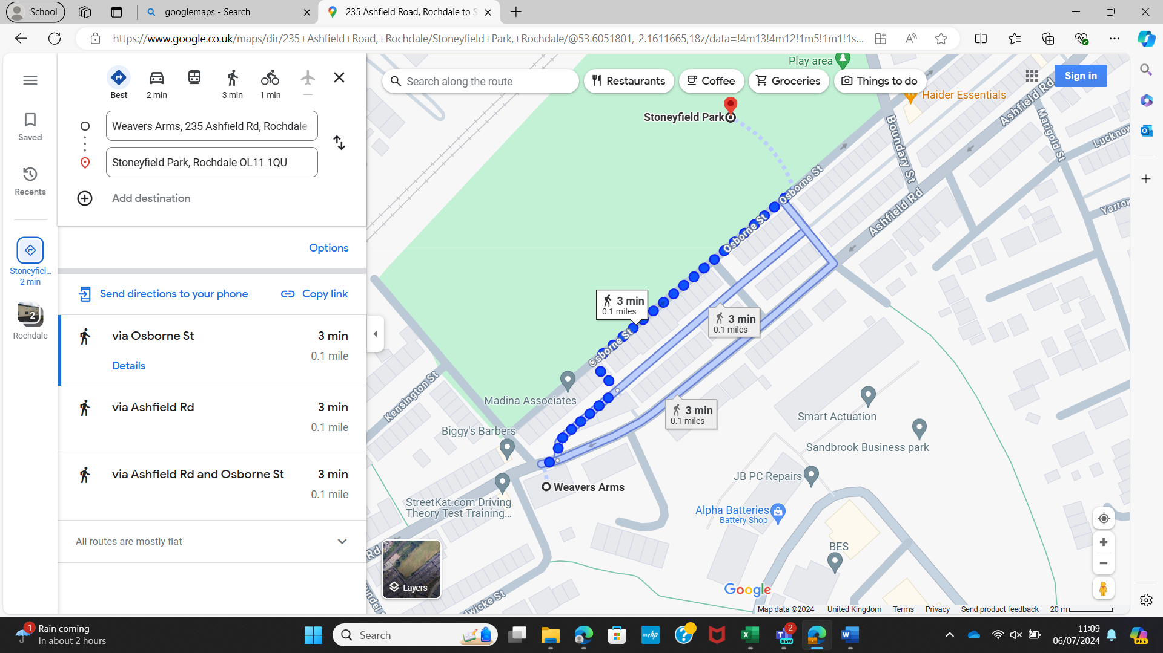

**RISK ASSESSMENT**

|  |  |
| --- | --- |
| Main Hazards:- | Who May Be Harmed:- |
| **Traffic, Slips, trips & falls, Lost children, Injury from sporting activity, Members of the general public, Protection of all vulnerable children** | Children, accompanying adults, general public, staff |

Risk level: VU = very unlikely, U = unlikely, L = likely, VL = very likely

Severity: L = slight (minor injury, cuts etc), M = serious (brakes, sprains, head injuries, electric shocks, back injury), H = Fatal (death)

|  |  |  |  |
| --- | --- | --- | --- |
| **HAZARD** | **CONTROL MEASURES THAT YOU SHOULD CONSIDER** | **RISK LEVEL** | **SEVERITY** |
| Traffic | * Walking the short distance to the playing fields * Crossing the road (side and main) to get to the field * Ensure children area aware of strict guidelines on behaviour * Good supervision with adequate ratios | L | M - H |
| Slips, trips & falls | * Ensure that parents & carers are aware of the clothing requirements needed (uniform). All children should wear appropriate footwear for walking and for any activity they will participate in. Make sure the equipment is appropriate for the activity and if any protective equipment required for the said activity. * Make sure everyone has weather appropriate clothing as some areas may be more at risk for slips and falls * Use main pathways which are maintained by the Council Highways * If you see something that has the potential to cause injury then you avoid that area and find another suitable area | L | L - M |
| Lost children | * Make sure you have clear objectives so that the children know what is expected of them if they become lost. Make them aware that they must not give their name to anyone unless they are the Police or someone they know and trust. * Ensure you have your ratio of supervisors to children correct and that they are aware of their responsibilities * Periodically check that your group is intact. * Staff to be stationed in the right points such as the boundary. | U | L - M |
| Injury and /or Insects/wasp stings/bites | * Always ensure there is adequate supervision of children * Remind children to report immediately if they are bitten by any insects, wasps etc. * Treat all cuts, bites, etc. immediately & cover adequately. * Ensure first aid box is available * Ensure Team Leaders have a charged and working mobile phone available | L | L - M |
| Members of the general public | * Clear instructions to be given to children and supervisors about the importance of not talking to strangers * Children should be supervised at all times so they are not put into a vulnerable position with the general public | L | L - M |
| Play areas | * Children must be supervised in the field and the outdoor play areas. * Children must wear appropriate footwear and clothing for each area. * Supervisors should use common sense and supervise children accordingly. | U - L | L - M |
| Protection Of Vulnerable children | * Carefully choose any volunteers. It is essential to ensure that all volunteers have a current enhanced CRB check and that it has been checked as sufficient. * Ensure everyone is aware of their responsibilities and have an understanding of the School Policy on protection of vulnerable children. | U - L | M - H |

|  |  |
| --- | --- |
| **Assessor** | Headteacher |